February 27, 2003

Contact:
Steve Pon, 415/441-4777, spon@sfmoma.org
Sandra Farish Sloan, 415/357-4174, ssloan@sfmoma.org

SFMOMA ARTISTS GALLERY PRESENTS
THE TENTH ANNUAL ARTISTS WAREHOUSE SALE

May 7–11, 2003

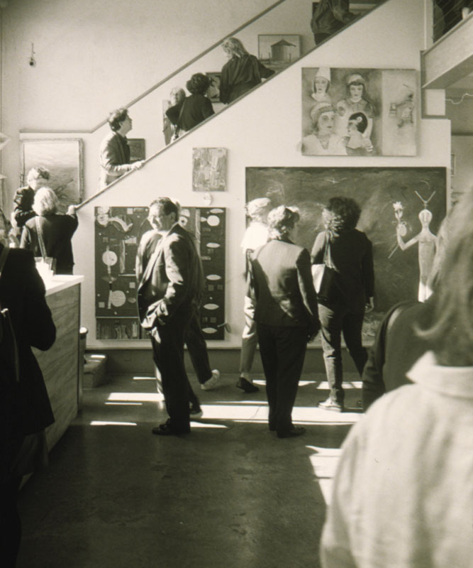
The San Francisco Museum of Modern Art (SFMOMA) Artists Gallery presents its tenth annual Artists Warehouse Sale from May 7 through 11, 2003, at Fort Mason Center, Building A. Consistently one of the year’s most anticipated art events and annual fund-raisers, this benefit sale includes a variety of works created by more than 350 invited West Coast artists, including Inez Storer, Mike Henderson, Terry Hoff, Leo Bersamina and Claire Cotts. All artworks, some of which have been made especially for this event, will be offered at 50 percent off the normal retail price. This year a bounty of exceptional work is expected from the artists’ donations.
SFMOMA Artists Gallery; Tenth Annual Warehouse Sale;
May 7 – 11, 2003
Proceeds from the Artists Warehouse Sale support the SFMOMA Artists Gallery’s exhibition program, which promotes regional art, SFMOMA and the artists themselves. A festive grand opening reception, complete with refreshments and live music, will kick off the sale on Wednesday, May 7, from 6 to 9 p.m. During the week of the sale, the gallery will offer special extended hours:

Wednesday, May 7 6–9 p.m. (opening and reception)
Thursday, May 8 noon–8 p.m.
Friday, May 9 noon–8 p.m.
Saturday, May 10 noon–5:30 p.m.
Sunday, May 11 noon–4 p.m.

Although the gallery restocks sale works daily, visitors are encouraged to attend early for the best selection.

Established in 1978, the SFMOMA Artists Gallery provides exposure and support to West Coast artists. Now representing more than 1,300 artists, the gallery serves a broad range of corporate and individual patrons through its art rental and sales operations. The SFMOMA Artists Gallery mounts approximately 10 exhibitions per year, showcasing Bay Area contemporary artists working in all media.

* * *
Visit our Web site at www.sfmoma.org or call 415/441-4777 for more information.

The San Francisco Museum of Modern Art is a private, not-for-profit institution supported by its members, individual contributors to Donor Circle, corporate and foundation support, federal and state government grants and admission revenues. Annual programming is sustained through the generosity of Grants for the Arts/San Francisco Hotel Tax Fund and The James Irvine Foundation. Thursday evening half-priced admission is sponsored by Banana Republic. Reduced admission for seniors is sponsored by Pacific Bell. KidstART free admission for children 12 and under is made possible by The Charles Schwab Corporation Foundation.
# # #

